**Bug Resolution Application Management**

**(Web Application)**

**Technologies: Django**







Table Of Contents

# Problem Statement

* Objectives and Benefits

# Steps Followed

* Visualizations





Problem Statement

As we Know the IT technology is growing up day by day. And with the advancement in technology users facing issues while learning this technologies. There are many communities where users post there questions/queries and get answer related to these questions. The main example of this type of community is stack over flow. So in this project created a bug resolution app using Django. Where developers post there queries and other developers answers there questions

The goal of this project is to make a website where user post there questions and other people answers there questions. A web application where developers can suggest the solution for any specific issue.



# Objective:



Objective and Benefits

* Create a platform where user post there daily problem related to software or IT domain.
* The aim of this project is to use the given a platform where people help each other.

# Benefits:

* User Post there question and other user help him to solve their problem.
* User can search there problem so if the problem is solved it easy to learn from it or simply go to the tag search and find tags that are related to it





Steps Followed

* 1. **Authentication**: This step involves login and registration of user.
  2. **User profile**: Once the user register there self they have the functionality to edit their info in the user profile page.
  3. **Question**: User can post there question in ask question page where we provide a best editor to format there post
  4. **Answer**: User can post answer related to some question in question page where we provide a best editor to format there post
  5. **Tags**: User can see that on which tag how much question is asked and can go to certain tag questions
  6. **Deployment**: this system is deployed on heroku platform and is live know.





Main Page :



System overview:

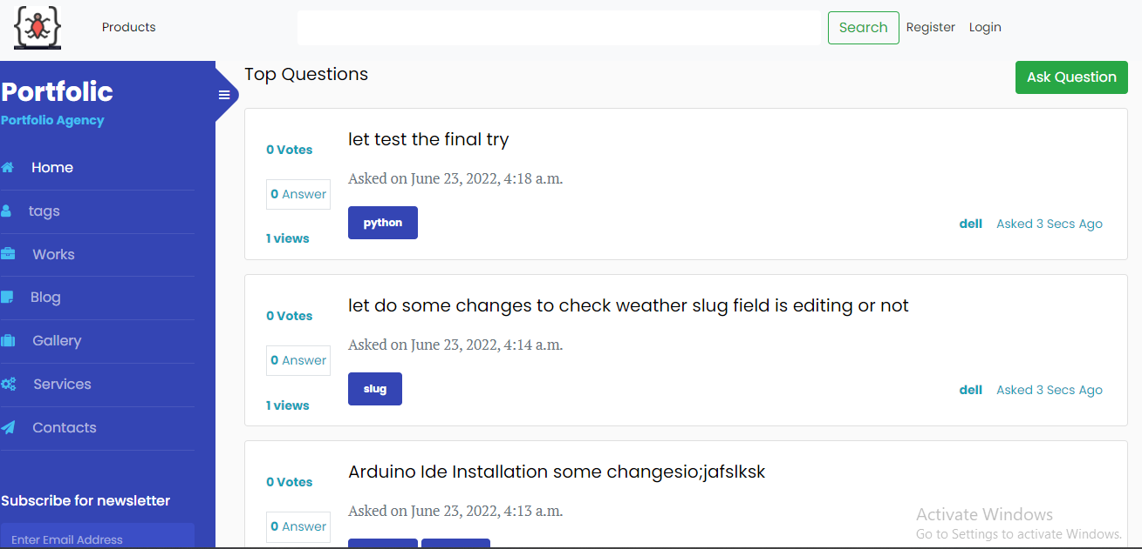

Login Page:







Signup Page







Ask Question

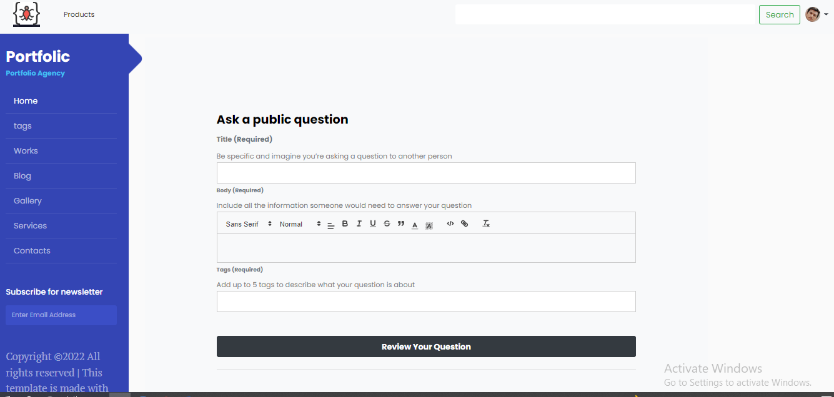

Question Page

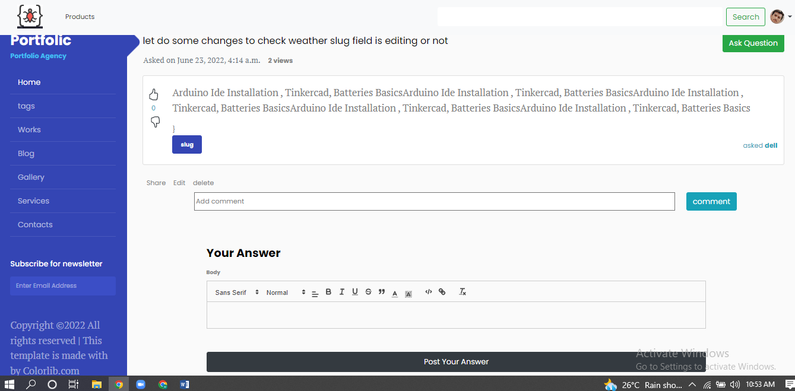

Tags Page:

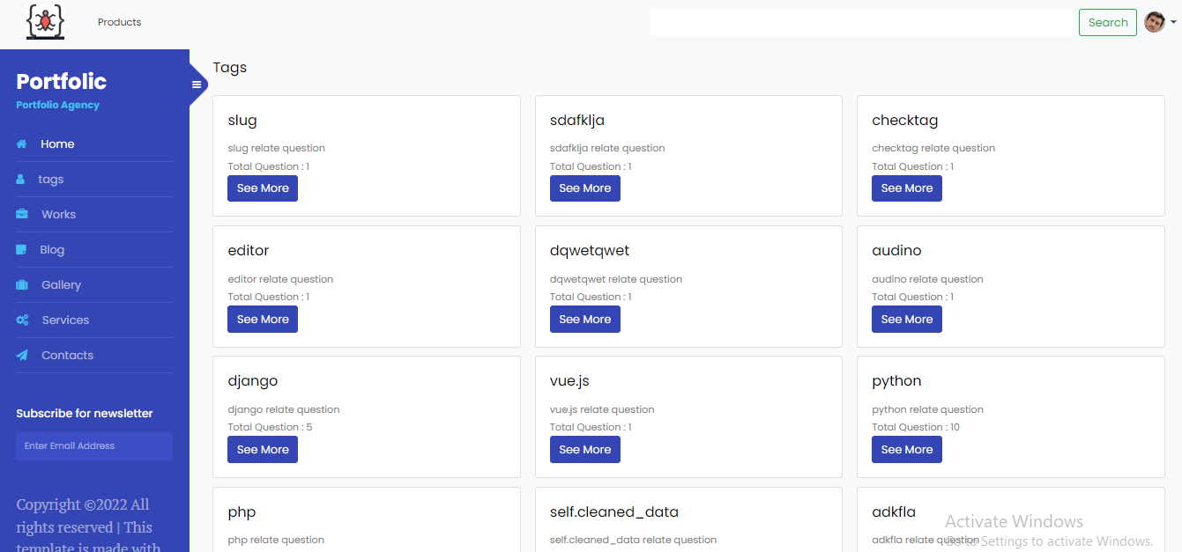













Thank You